Software Development Life Cycle (SDLC) – Detailed Documentation

1. Introduction
The Software Development Life Cycle (SDLC) is a systematic process for planning, creating, testing, and deploying software applications. It ensures that software is delivered with high quality, within time, and within budget.
SDLC defines a clear structure for the development team and helps reduce project risks by breaking the entire process into manageable phases.
SDLC is widely used in software engineering, IT industries, and project management because it promotes disciplined development and ensures that every requirement of the client or user is properly addressed.

2. Objectives of SDLC
To deliver high-quality software
To complete the project within defined timelines
To reduce risks through proper planning and reviews
To provide a clear structure for team members
To ensure proper documentation at every stage
To enable testing, validation, and maintenance efficiently

3. Phases of SDLC
SDLC typically consists of 7 major phases:

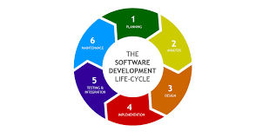

3.1 Requirement Analysis
This is the first and one of the most important stages. Here, the goal is to understand what the user needs.

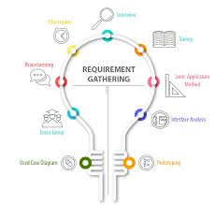

Activities:
Gathering functional and non-functional requirements
Interacting with stakeholders (clients, end-users, managers)
Creating requirement documents (SRS – Software Requirement Specification)
Outcome:
A clear list of system requirements documented in the SRS.

3.2 System Design
This phase defines how the software will work.

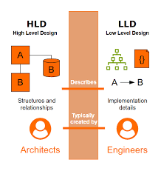
Activities:
Creating system architecture
Designing database structure, data flow, and user interface
Preparing high-level and low-level designs (HLD & LLD)
Outcome:
A complete design blueprint that developers will follow.

3.3 Implementation (Coding)
In this phase, developers convert design documents into actual source code.

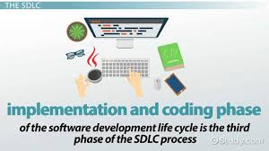

Activities:
Writing and structuring code modules
Following coding standards and best practices
Using version control systems (Git, GitHub)
Outcome:
The complete software product in code form.

3.4 Testing
To ensure the software works correctly and meets requirements, it goes through various testing processes.

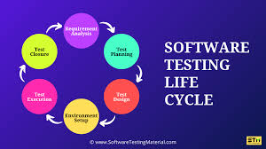

Types of Testing:
Unit testing
Integration testing
System testing
Performance testing
User acceptance testing (UAT)
Outcome:
A bug-free, stable product ready for deployment.

3.5 Deployment
After testing, the software is delivered to the customer or released for public use.

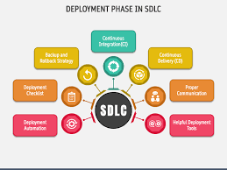

Deployment Options:
Local servers
Cloud-based platforms
Mobile app store releases
Outcome:
Software is now live and ready for use.

3.6 Maintenance
Once deployed, the software requires continuous updates and support.

Maintenance includes:
- Fixing bugs discovered after release
- Adding new features
- Performance improvements
- Security updates
Outcome:
Long-term reliability and continued user satisfaction.

4. Popular SDLC Models
Different SDLC models are used depending on project requirements.

4.1 Waterfall Model
A linear, step-by-step approach.
Best for: Small projects with fixed requirements.

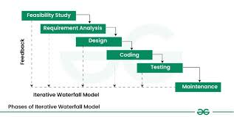

4.2 Agile Model
Iterative, fast, and flexible development.
Best for: Projects that require continuous updates and customer involvement.

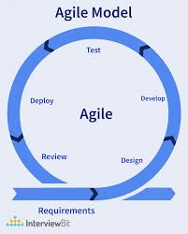

4.3 Spiral Model
Combines waterfall and iterative development with frequent risk analysis.
Best for: Large, high-risk projects.

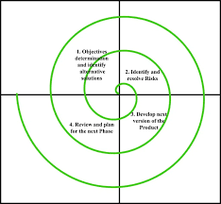

4.4 V-Model (Verification & Validation)
Each development stage has a corresponding testing stage.
Best for: Applications requiring strict testing.

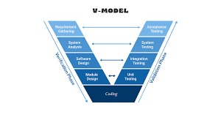

4.5 Iterative Model
Software is developed and improved in repeated cycles.
Best for: Projects where initial requirements are unclear.

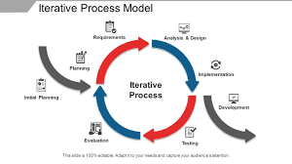

5. Importance of SDLC
- Improves project planning and management
- Enhances software quality
- Reduces development cost and time
- Ensures that client expectations are met
- Helps identify risks early
- Provides structured documentation

6. Real-World Example
Consider an online food delivery application:

- Requirement Analysis: Customer registration, restaurant listings, menu display, payments, delivery tracking.
- Design: System architecture, database design for users, orders, restaurants
- Coding: Frontend (Flutter/React), Backend (Node.js/Python), Database (MySQL/MongoDB)
- Testing: Check login, order placement, payment gateway, tracking
- Deployment: Release app on Play Store/App Store
- Maintenance: Regular updates, bug fixes, new features like wallet or discounts

7. Conclusion
SDLC provides a well-organized method to plan, design, develop, test, deploy, and maintain software. It ensures efficiency, reduces development risks, and helps teams deliver high-quality products consistently.
Understanding SDLC is essential for developers, testers, project managers, and anyone involved in software production.

